# INTRODUCTION:

* 1. **Project Overview**

The **Electricity Consumption Analysis** project aims to study and visualize electricity usage patterns across different regions and time periods using **Tableau**. The project analyzes large datasets related to electricity consumption to identify trends, seasonal variations, and demand patterns. By converting raw data into **interactive dashboards and visual reports**, the project helps in understanding how electricity is consumed across regions, time frames, and usage categories. This visual approach simplifies complex data and enables stakeholders to gain insights quickly and effectively.

The primary purpose of this project is to assist **energy analysts, policymakers, utility providers, and decision-makers** in understanding electricity consumption behavior. Using a data-driven approach, the project allows users to explore consumption trends, peak demand periods, and regional variations. These insights support better decision-making in areas such as **energy planning, demand forecasting, resource optimization, and policy formulation**, ultimately contributing to efficient and sustainable energy management.

# IDEATION PHASE

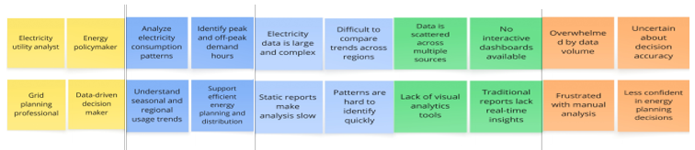 **2.1 Problem Statement Customer problem statement**

|  |  |  |  |  |  |
| --- | --- | --- | --- | --- | --- |
| **Problem Statement (PS)** | **I am (Customer)** | **I’m trying to** | **But** | **Because** | **Which makes me feel** |
| PS-1 | an electricity utility analyst | identify peak electricity demand patterns | data is scattered and complex | there’s no unified visual dashboard | unsure about demand planning |
| PS-2 | an energy policymaker | track regional electricity consumption trends | I can’t compare trends easily | dashboards aren’t interactive | frustrated and uncertain |

**2.2 Empathy Map Canvas**

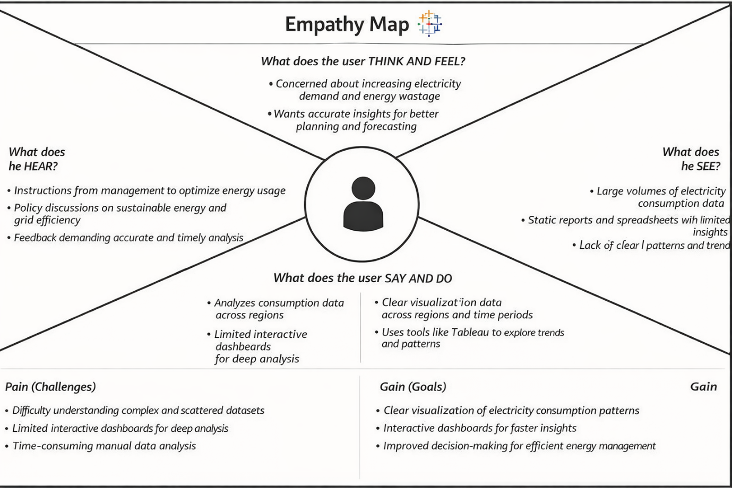

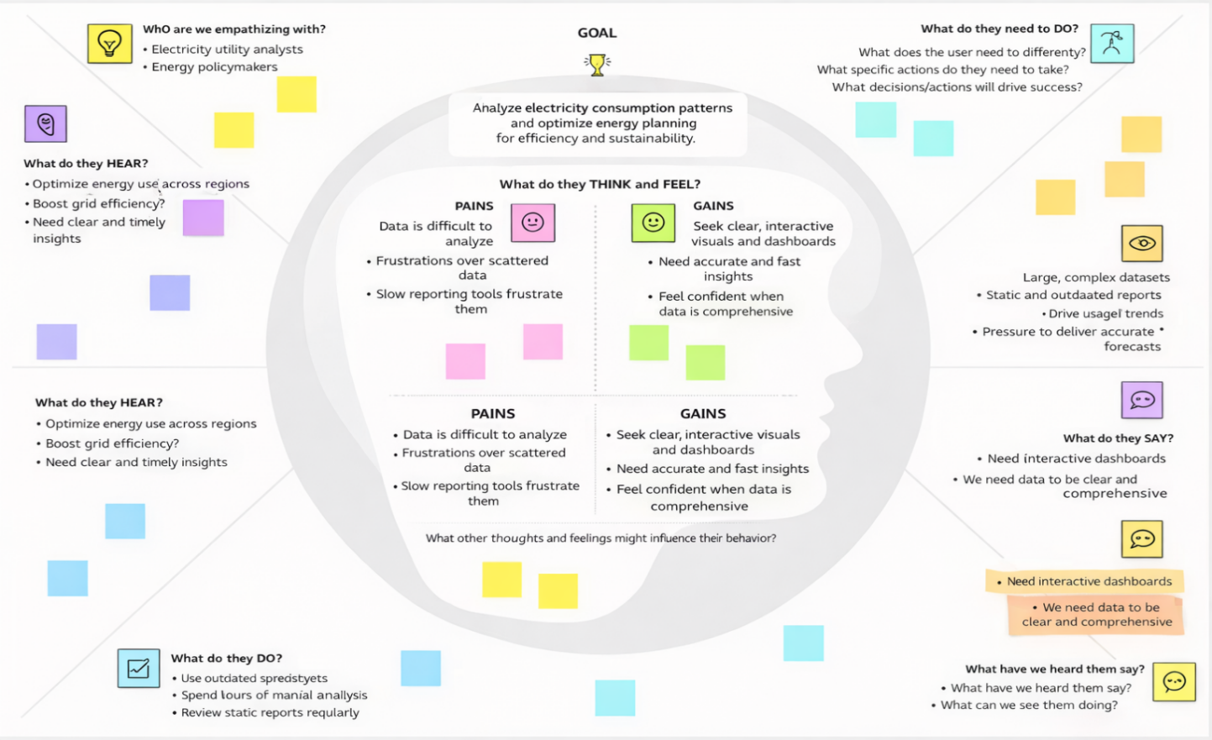

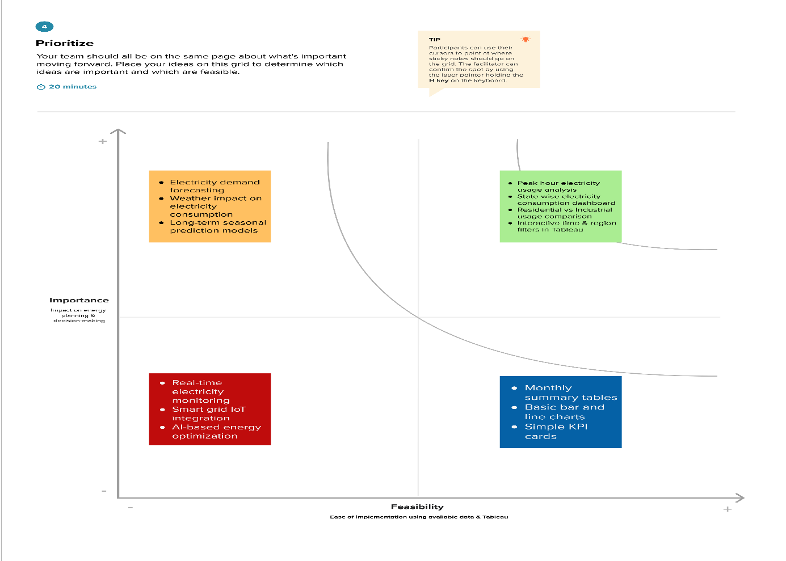

* 1. 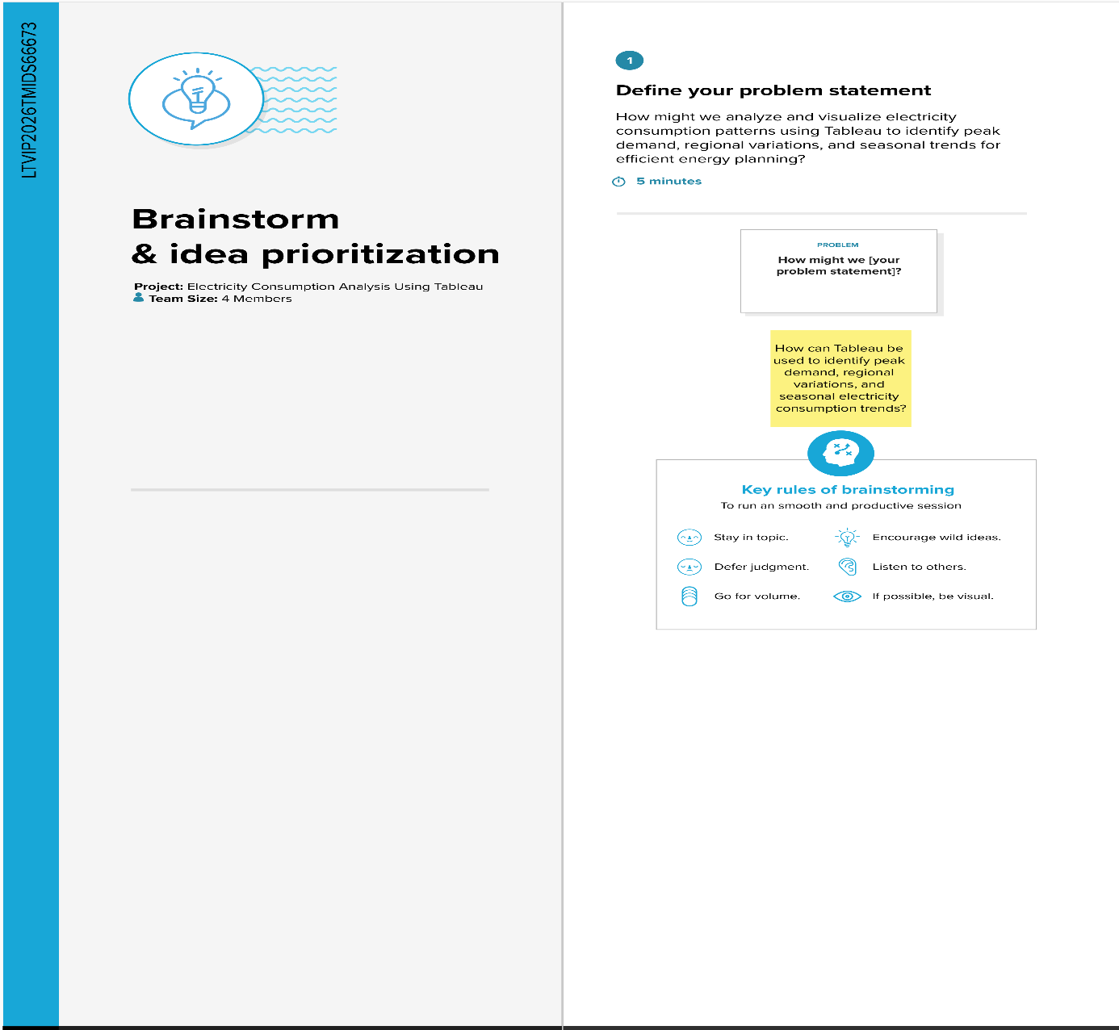**Brainstorming**

# 3. REQUIREMENT ANALYSIS

**3.1 Customer Journey map**

|  |  |  |  |  |  |
| --- | --- | --- | --- | --- | --- |
| Stage | Need | Action | Touchpoint | Pain Point | Opportunity |
| Discover | Wants iPhone market trends | Searches Excel/market data | Emails, Files | Data is scattered | Single dashboard entry point |
| Explore | Needs regional & feature insights | Browses charts manually | Spreadsheets, BI tools | Time-consum ing | Filter-enabled Tableau dashboard |
| Engage | Wants to compare specs vs pricing | Tries custom visualizations | Excel formulas | Lacks interactivity | Pre-built price/spec dashboard |
| Decide | Prepares pitch for leadership | Screenshots graphs | Presentations | Dry data storytelling | Use Tableau story points with captions |

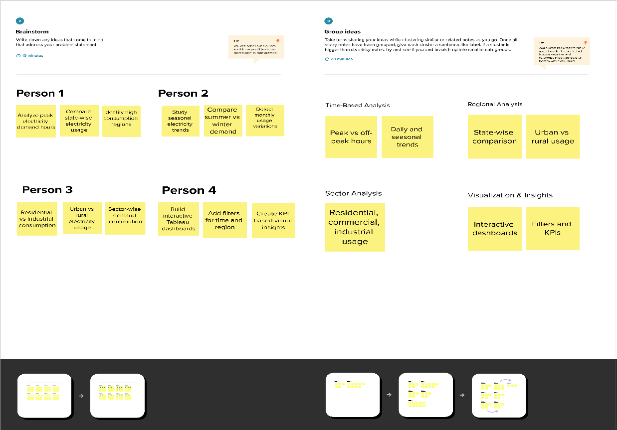

**3.2 Solution Requirement**

**Functional Requirements:**

|  |  |  |
| --- | --- | --- |
| **FR No.** | **Functional Requirement (Epic)** | **Sub Requirement (Story / Sub-Task)** |
| FR-1 | |  | | --- | | User Authentication |  |  | | --- | |  | | |  | | --- | | User login through username & password |  |  | | --- | |  | |
| FR-2 | |  | | --- | | Data Upload |  |  | | --- | |  | | |  | | --- | | Upload electricity consumption datasets (CSV/Excel) |  |  | | --- | |  | |
| FR-3 | |  | | --- | | Data Validation |  |  | | --- | |  | | |  | | --- | | Validate missing values and incorrect data |  |  | | --- | |  | |
| FR-4 | |  | | --- | | Data Processing |  |  | | --- | |  | | |  | | --- | | Process data using Flask backend |  |  | | --- | |  | |
| FR-5 | |  | | --- | | Data Storage |  |  | | --- | |  | | |  | | --- | | Store processed data in database |  |  | | --- | |  | |
| FR-6 | |  | | --- | | Data Visualization |  |  | | --- | |  | | |  | | --- | | Generate interactive Tableau dashboards |  |  | | --- | |  | |

**3.3 Data Flow Diagram**

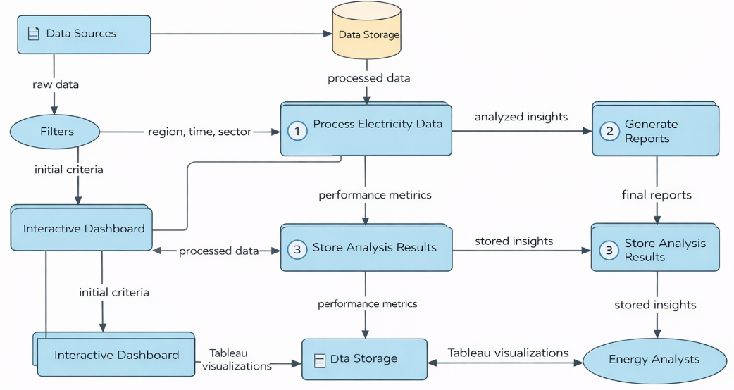

* 1. **Technology Stack**

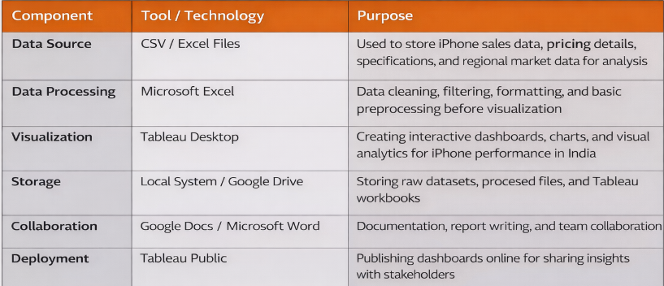

4. PROJECT DESIGN

4.1 **Problem Solution Fit**  
  
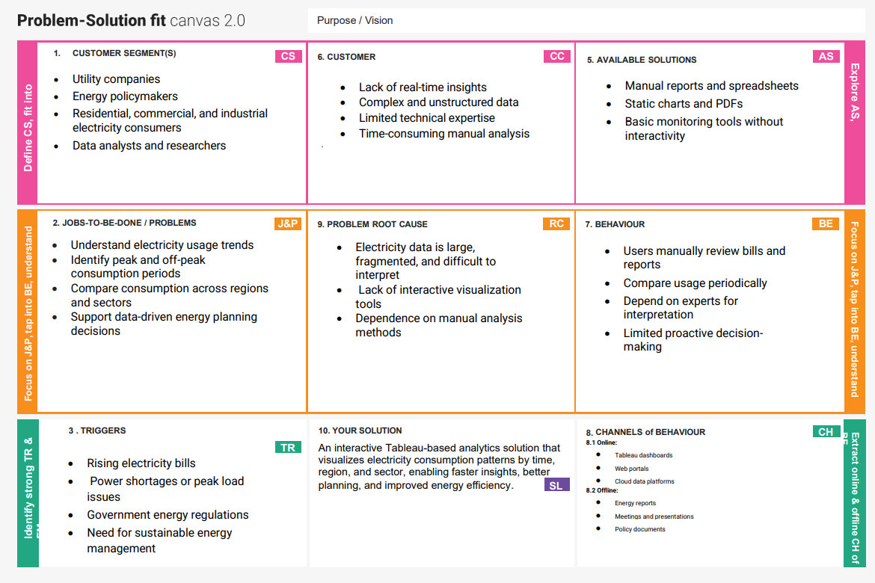

* 1. **Proposed Solution**

|  |  |  |
| --- | --- | --- |
| **S.No.** | **Parameter** | **Description** |
|  | Problem Statement (Problem to be solved) | Manual analysis of electricity consumption data is time-consuming and does not clearly reveal peak demand, seasonal trends, or regional usage patterns, making efficient energy planning difficult. |
|  | Idea / Solution description | |  | | --- | | The solution analyzes electricity consumption data using Python and visualizes insights through interactive Tableau dashboards to identify peak demand, seasonal trends, and regional variations. | |
|  | Novelty / Uniqueness | |  | | --- | | Integrates automated data processing with interactive Tableau dashboards, allowing users to dynamically explore electricity usage without technical expertise. |  |  | | --- | |  | |
|  | Social Impact / Customer Satisfaction | |  | | --- | | Helps energy providers and policymakers optimize electricity usage, reduce wastage, and improve planning, resulting in better service reliability and customer awareness. |  |  | | --- | |  | |
|  | Business Model (Revenue Model) | |  | | --- | | Offered as a subscription-based dashboard, licensed analytics tool for energy agencies, or a consulting solution for electricity consumption analysis. |  |  | | --- | |  | |
|  | Scalability of the Solution | Scalable architecture supports large datasets, cloud storage, and future integration of additional regions, years, or real-time electricity data. |

# 4.3 Solution planning

# 

# 5. PROJECT PLANNING & SCHEDULING

* 1. **Project Planning**

| **Sprint** | **Functional Requirement (Epic)** | **User Story Number** | **User Story / Task** | **Story Points** | **Priority** | **Team Members** |
| --- | --- | --- | --- | --- | --- | --- |
| Sprint-1 | |  | | --- | |  |  |  | | --- | | Data Collection | | USN-1 | as user, I can upload electricity consumption datasets (CSV/Excel) into the system. | 2 | High | Member-1 |
| Sprint-1 | |  | | --- | |  |  |  | | --- | | Data Pre-processing | | USN-2 | |  | | --- | | As a user, I want the system to clean and preprocess raw electricity data automatically. |  |  | | --- | |  | | 2 | High | Member-2 |
| Sprint-1 | |  | | --- | | Data Storage |  |  | | --- | |  | | USN-3 | |  | | --- | | As a user, I want the processed data to be stored securely for analysis. |  |  | | --- | |  | | 1 | Medium | |  | | --- | |  |  |  | | --- | | Member-3 | |
| Sprint-2 | |  | | --- | | Data Analysis |  |  | | --- | |  | | USN-4 | |  | | --- | | As a user, I can analyze electricity consumption trends such as peak demand and seasonal patterns. |  |  | | --- | |  | | 3 | High | Member-1 |
| Sprint-2 | Visualization | USN-5 | |  | | --- | | As a user, I can view interactive dashboards in Tableau for better insights. |  |  | | --- | |  | | 3 | High | Member-2 |
| Sprint-2 | |  | | --- | | Dashboard Filters |  |  | | --- | |  | | USN-6 | |  | | --- | | As a user, I can filter data by region, time period, and consumption type. |  |  | | --- | |  | | 2 | Medium | Member-4 |
| Sprint-3 | |  | | --- | | Performance Optimization |  |  | | --- | |  | | USN-7 | |  | | --- | | As a user, I want dashboards to load quickly even for large datasets. |  |  | | --- | |  | | 2 | Medium | |  | | --- | |  |  |  | | --- | | Member-3 | |
| Sprint-3 | |  | | --- | | Reporting |  |  | | --- | |  | | USN-8 | |  | | --- | | As a user, I can export visualizations and reports for decision-making. |  |  | | --- | |  | | 1 | Low | Member-4 |

# 7.FUNCTIONAL AND PERFORMANCE TESTING

# 5.2 Performance Testing

|  |  |  |
| --- | --- | --- |
| **S.No.** | **Parameter** | **Screenshot / Values** |
| 1. | Data Rendered | |  | | --- | | Electricity consumption dataset loaded successfully into  Tableau with multiple dimensions (Date, Region,  Consumption Type) and measures (Units Consumed). | |
| 2. | Data Preprocessing | |  | | --- | | Data cleaning performed: null values handled, date  formats standardized, unnecessary columns removed,  and data aggregated at monthly and regional levels. |  |  | | --- | |  | |
| 3. | Utilization of Filters | |  | | --- | | Data cleaning performed: null values handled, date  formats standardized, unnecessary columns removed,  and data aggregated at monthly and regional levels. |  |  | | --- | |  | |
| 4. | Calculation fields Used | |  | | --- | | Data cleaning performed: null values handled, date formats standardized, unnecessary columns removed, and data aggregated at monthly and regional levels. |  |  | | --- | |  | |
| 5. | Dashboard design | No of Visualizations / Graphs - **6** (Bar Chart, Line Chart, Heat Map, KPI Cards, Pie Chart, Trend Analysis). |
| 6 | Story Design | No of Visualizations / Graphs -: **4** (Consumption Trends, Regional Comparison, Seasonal Patterns, Key Insights Summary). |

**7.Results**

**7.1 output screenshorts**

**Dashboards**  
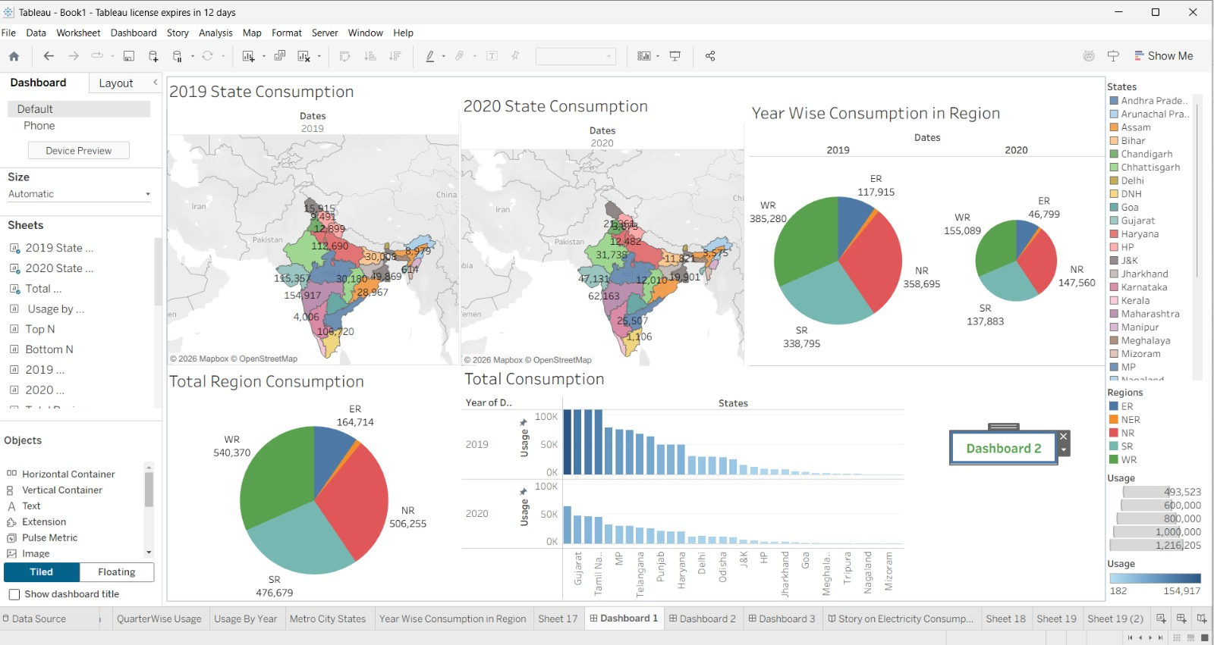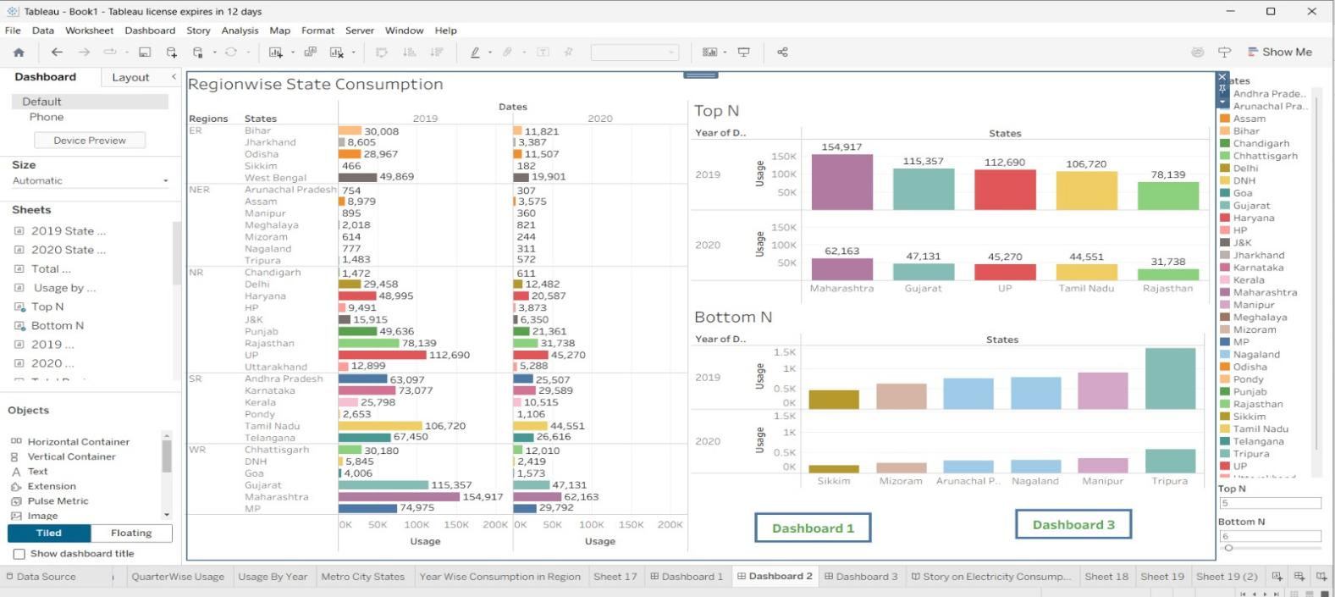

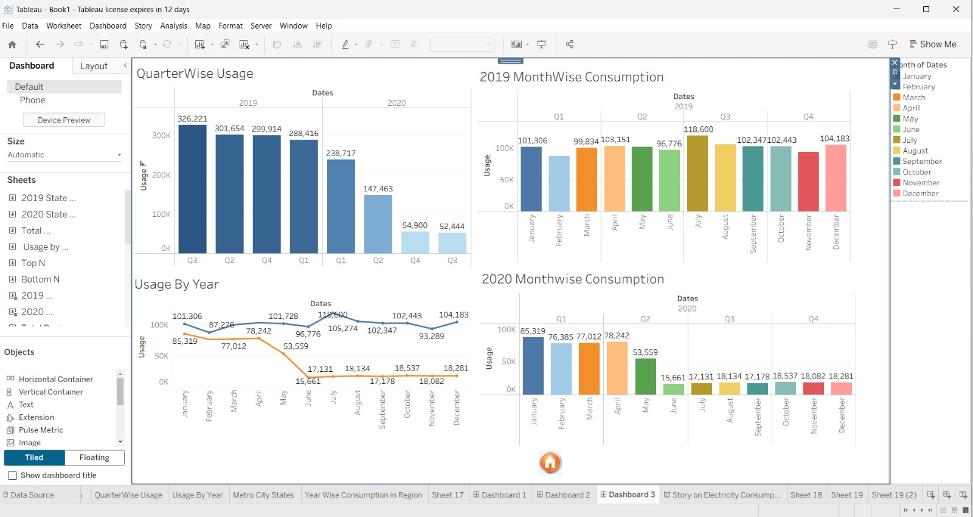

**STORY OUTPUTS:**

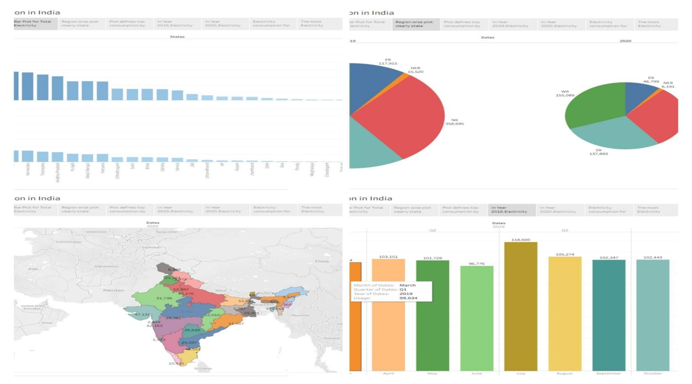

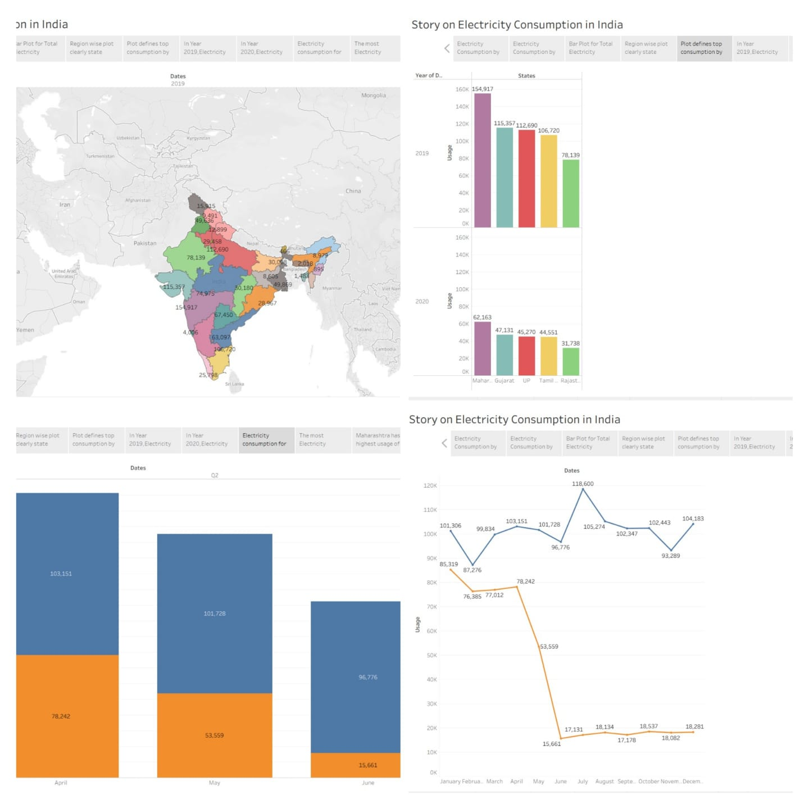

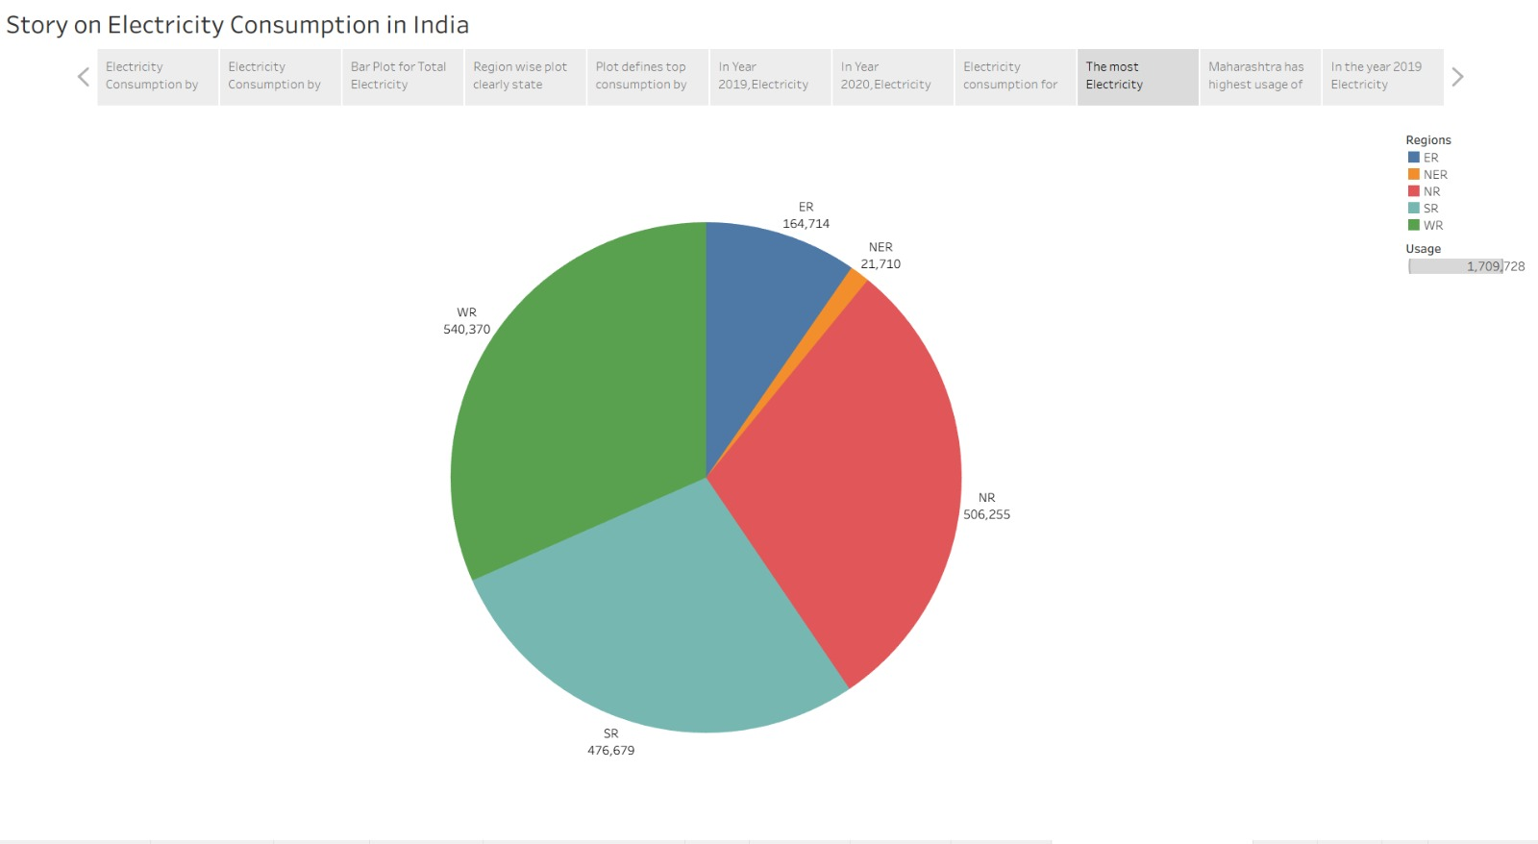

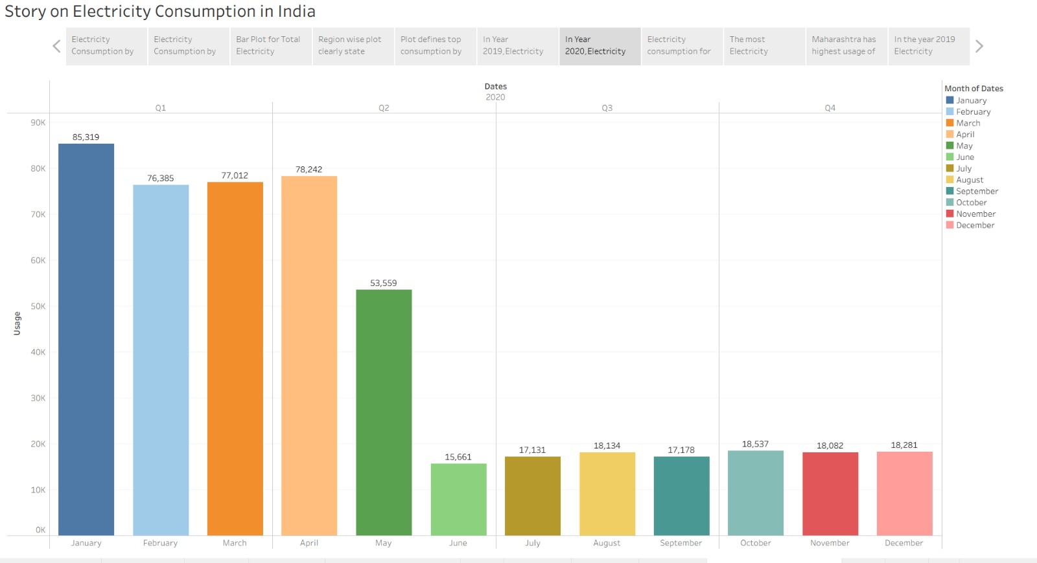



**8. ADVANTAGES & DISADVANTAGES**

**ADVANTAGES**

* **Clear Visualization of Complex Data**  
  Tableau converts large electricity consumption datasets (state-wise, region-wise, monthly, yearly) into easy-to-understand charts, maps, and dashboards.
* **Geographical Insights**  
  The map visualization helps identify high-consumption and low-consumption states across India, which is difficult to understand using tables alone.
* **Time-Saving Analysis**  
  Pre-built dashboards and stories reduce manual calculations and speed up data analysis for decision-making.
* **Better Decision Making**  
  Useful for policymakers, planners, and researchers to make data-driven decisions related to energy distribution and planning.

**DISADVANTAGES**

* **Dependency on Data Quality**  
  The accuracy of insights depends entirely on the correctness and completeness of the electricity consumption data used.
* **Limited Advanced Analysis**  
  Tableau is mainly for visualization; complex statistical or predictive analysis requires external tools.
* **Static Nature of Stories**  
  Tableau Stories are less flexible for dynamic narration compared to fully interactive dashboards.
* **Performance Issues with Large Data**  
  Handling very large datasets may slow down performance on low-end systems.
* **Learning Curve**  
  Beginners may find Tableau features (calculations, parameters, story points) difficult to learn initially.

**9. CONCLUSION**

The Electricity Consumption Analysis project successfully demonstrates how **data visualization and interactive dashboards** can transform large and complex energy datasets into meaningful insights. By integrating **state-wise, region-wise, monthly, quarterly, and geographical electricity consumption data** into Tableau dashboards and stories, the project simplifies analysis and enhances understanding of consumption patterns across India.

The use of **interactive charts, maps, and filters** enables users to explore trends efficiently and compare electricity usage across different years and regions world electricity consumption data effectively.

1. **FUTURE SCOPE**

* **Multi-Year Analysis:**  
  Extend the dataset to include additional years for long-term trend analysis and forecasting.
* **Real-Time Data Integration:**  
  Connect live data sources such as government electricity portals or APIs to enable automatic dashboard updates.
* **Advanced Forecasting:**  
  Apply predictive analytics to forecast future electricity demand at the state and regional levels.
* **Sector-Wise Consumption Analysis:**  
  Include industrial, residential, commercial, and agricultural electricity usage for deeper insights.
* **Mobile and Web Optimization:**  
  Optimize dashboards for mobile devices and web platforms to improve accessibility for decision-makers.

**11. APPEND**

**Dataset Link:** <https://drive.google.com/file/d/1JxIkHNwXxjFztKq7ad0_KtkukCqTckNy/view?usp=sharing>

**GitHub Link:**

**Project Demo Link:**